P:\ADMIN\WEBSITE\OPENCITIES\WEBSITE FORMS\RESIDENTIAL PERMITS\2021 Energy Efficiency Form.docx
Page 1 of 2
BUILDING COMPONENT | REQUIRED PERFORMANCE | EQUIVALENT VALUE
Wall insulation | U-0.083 | R-15
Flat ceiling | U-0.025 | R-49
Vaulted ceiling > 10 inches nominal rafter depth | U-0.040 | R-25
Vaulted ceiling > 8 inches nominal rafter depth | U-0.047 | R-21
Underfloor > 10 inches nominal joist depth | U-0.028 | R-30
Underfloor > 8 inches nominal joist depth | U-0.039 | R-25
Slab-edge perimeter | F-0.52 | R-15
Windows | U-0.30 | U-0.30
Skylights | U-0.50 | U-0.50
Exterior doors | U-0.20 | R-5
Exterior doors with > 2.5ft2 glazing | U-0.40 | R-2.5
Forced air ducts | n/a | R-8

Residential Energy Additional
Measure Selection – 2021 ORSC

RESIDENTIAL INFORMATION
Date: Permit Number:

Applicant’s Name: Signature:
Job Address: City: State: Zip:
INSTRUCTIONS
Please select type of construction below; sign, date, and complete the entire form. Submit this form with your permit application
or your project will be placed on hold until the required information is provided.
New construction. All conditioned spaces within residential buildings must comply with Table N1101.1(1) and one additional measure from Table N1101.1(2) on page 2.

Additions. Additions to existing buildings or structures may be made without making the entire building or structure comply if the new additions comply with the requirements of this chapter. (N1101.3)
Large additions. Additions that are equal to 600 square feet (55 m2) in area must comply with Table N1101.1(2) on page 2. (N1101.3.1) (Note: You must select one measure.)
Small additions. Additions that are less than 600 square feet in area must select one measure from Table N1101.1(2) on page 2 or comply with Table N1101.3 on page 2. (N1101.3.2)

Exception: Additions that are less than 225 square feet in area are not required to comply with Table N1101.1(2) or Table N1101.3.
Change of use or occupancy TABLE N1101.2
See additional information on page 3 EXISTING BUILDING COMPONENT REQUIREMENTS
of this document for further
clarification.

Note: N1101.2.3 change of occupancy or use. Definition of “Change of use” for purposes of Section N1101.2.3 is a change of use in an existing residential building and shall include any of the following: any unconditioned spaces such as an attached garage, basement, porch, or canopy that are to become conditioned spaces; any unconditioned, inhabitable space that is to become conditioned space, such as a large attic. N1101.2.3.1 Change of use. See section N1101.2.3.2 Change of occupancy. See section.

For SI: inch-25.4mm, 1 square foot = 0.0929m2
Page 1 of 3

TABLE N1101.3 – SMALL ADDITION ADDITIONAL MEASURES (SELECT ONE)
Page 2 of 2
P:\ADMIN\WEBSITE\OPENCITIES\WEBSITE FORMS\RESIDENTIAL PERMITS\2021 Energy Efficiency Form.docx
 |  | 1 | Increase the ceiling insulation of the existing portion of the home as specified in Table N1101.2.
 |  | 2 | Replace all existing single-pane wood or aluminum windows to be U-value as specified in Table N1101.2.
 |  | 3 | Insulate the existing floor, crawl space or basement wall systems as specified in Table N1101.2 and install 100  percent of permanently installed lighting fixtures as CFL, LED or linear fluorescent, or a minimum efficacy of 40 lumens per watt as specified in Section N1107.2.
 |  | 4 | Test the entire dwelling with blower door and exhibit no more than 4.5 air changes per hour @ 50 Pascals.
 |  | 5 | Seal and performance test the duct system.
 |  | 6 | Replace existing 80 percent AFUE or less gas furnace with a 92 percent AFUE or greater system.
 |  | 7 | Replace existing electric radiant space heaters with a ductless mini-split system with a minimum HSPF of 10.0.
 |  | 8 | Replace existing electric forced air furnace with an air source heat pump with a minimum HSPF of 9.5.
 |  | 9 | Replace existing water heater with a water heater meeting:  - Natural gas/propane water heater with minimum UEF 0.90, or  - Electric heat pump water heater with minimum 2.0 COP

TABLE N1101.1(2) ADDITIONAL MEASURES
1 | HIGH EFFICIENCY HVAC SYSTEM  - Gas-fired furnace or boiler AFUE 94%, or  - Air source heat pump HSPF 10.0/14.0 SEER cooling, or  - Ground source heat pump COP 3.5 or Energy Star rated
2 | HIGH EFFICIENCY WATER HEATING SYSTEM  - Natural gas/propane water heater with minimum UEF 0.90, or  - Electric heat pump water heater with minimum 2.0 COP, or  - Natural gas/propane tankless/instantaneous heater with minimum 0.80 UEF and  Drain Water Heat Recovery Unit installed on minimum of one shower/tub-shower
3 | WALL INSULATION UPGRADE  Exterior walls – U-0.045/R-21 conventional framing with R-5.0 continuous insulation
4 | ADVANCED ENVELOPE  Windows - U-0.21 (Area weighted average), and Flat ceiling – U-0.017/R-60, and  Framed floors - U-0.026/R-38 or slab edge insulation to F-0.48 or less (R-10 for 48”; R-15 for  36” or R-5 fully insulated slab)
5 | DUCTLESS HEAT PUMP  For dwelling units with all-electric heat provide:  - Ductless heat pump of minimum HSPF 10 in primary zone replaces zonal electric heat  - Programmable thermostat for all heaters in bedrooms
6 | HIGH EFFICIENCY THERMAL ENVELOPE UA  Proposed UA is 8 percent lower than the code UA
7 | GLAZING AREA  Glazing area, measured as the total of framed openings is less than 12 percent of conditioned  floor area
8 | 3 ACH AIR LEAKAGE CONTROL AND EFFICIENT VENTILATION  Achieve a maximum of 3.0 ACH50 whole-house air leakage when third-party tested and provide a whole-house ventilation system including heat recovery with a minimum  sensible heat recovery efficiency of not less than 66 percent

Choose one of the following methods to meet the Mechanical Whole-House Ventilation System
requirements (see BCD technical bulletin)
Supply and exhaust fans providing continuously-operating, balanced, WHV without a
furnace.
Supply and exhaust fans providing continuously-operating, balanced, WHV with a furnace.
Central Fan Integrated Supply (CFIs) continuously-operating, balanced WHV. Furnace serves as the intake fan. Shall be interlocked with exhaust system and an override switch.
Heat recovery/energy recovery ventilation providing continuously-operating, balanced, WHV. Supply may be connected to the central furnace return air.
Other approved method detailed on the construction documents. Reference page number _ __ _ .

Page 2 of 3

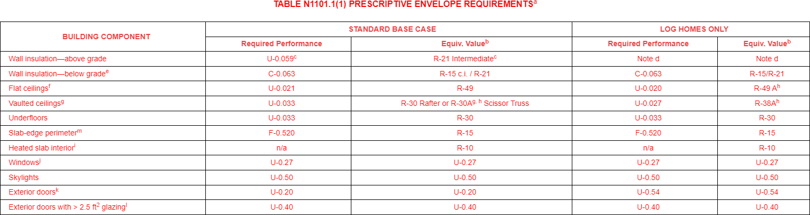

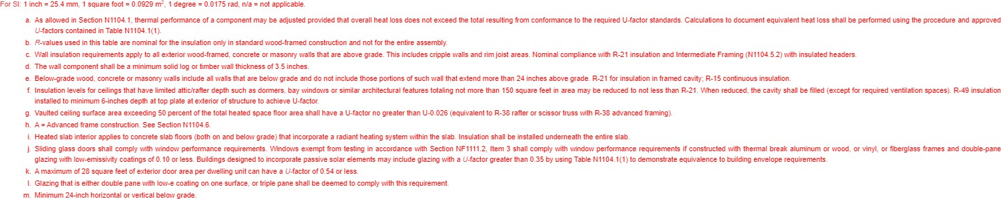
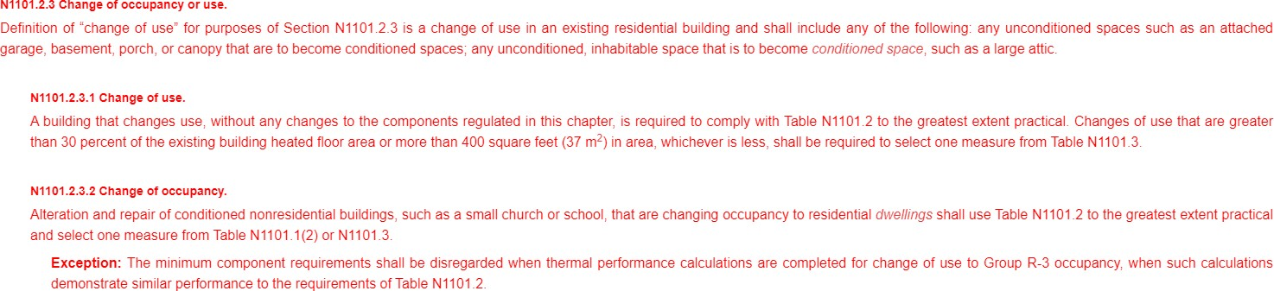

Page 3 of 3

